MATH-6792 Spring 2003
Mathematical Methods in Medical Imaging

Final Project

Wavelet Based Local Tomography

Ming Jiang <jiangm@rpi.edu>
Chih-ting Wu <wuc@rpi.edu>
Rensselaer Polytechnic Institute, Troy, NY

1. Introduction
It is a well known problem that the X-ray transform or the Radon transform are non-local in even dimensions, that is, the recovery of image at any fixed requires the information from all projections of the image. In many situations, a physician may be only interested in images of a very local area of body. The non-locality of Radon transform, however, forces patient to expose to relatively large amount of radiation even if it was desired to view only a small part of his body.
Several attempts have been developed to alleviate this problem. One approach is to do local tomography which reconstruct from local data, where only integrals over lines close to the point of interest are used. One of the topics of currently studied in tomography is using wavelets. The application of wavelet theory to inversion of the Radon transform was first proposed in [1] and [2]. Walnut in 1992 [3] reported an inversion formula based on the continuous wavelet. These ideas were used in an implementation by Olson & DeStefano [4], where radiation exposure was significantly reduced. Extensions and modifications to these methods have been made by Delaney & Bresler [5] and Rashid-Farrokhi et al. [6] and have led to successful local reconstruction algorithms. All authors just mentioned concentrate on using separable two dimensional wavelet bases. Peyrin & Zaim [7] proposed nonseparable wavelets and they claim that such wavelets give a more accurate reconstruction than separable wavelets. Another possible application of wavelets in tomography is denoising [8] or a combination of multiscale reconstruction and denoising [9]. Their methods are based on the idea that noise affects mostly the high frequency parts of an image and they have devised methods to remove noise from these parts of the reconstruction. In this, the wavelet decomposition provides a natural framework for dividing up an image in low and high resolution parts.
In this report, we reviewed the global tomographic and local tomographic problems., and the reason why wavelet is a nature tool for local tomography. We implemented local tomography algorithm using the time-frequency localization properties of wavelets, based upon conventional filtered backprojection method but replacing the ramp filter with wavelet ramp filter.

2 Preliminaries
2.1 Notations
Throughout this report,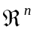 denote dimension Euclidean space. A vector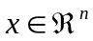 is written 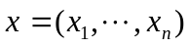.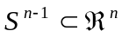denotes the (-1) dimension sphere, and 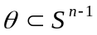 is written 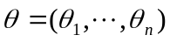.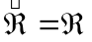,the dual of 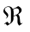, denotes the frequency domain. is the convolution operator.

2.2 Radon Transform
The Radon transform,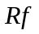, which integrateson along the affine hyperplane 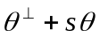, is defined by
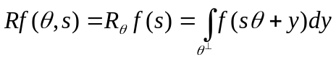 (1)
where 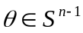, 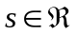, and 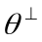 is the subspace perpendicular to .
Now we are interested in reconstructing local region of samples. This local problem or interior problem can be described as follows. Given > 0, find out the value of,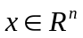, for all 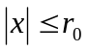, from knowledge of projections of on lines passing through the ball of radius about the origin, as Figure 1 shows.
We define the region of interest (ROI) by
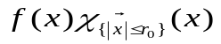 (2)
The interior Radon transform can be defined by
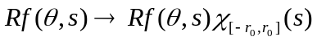 (3)
where 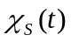=1 if is in the set , and = 0 otherwise.
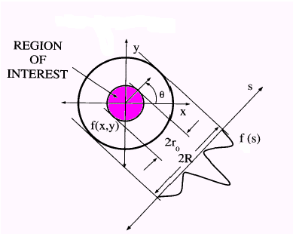Figure 1 The inner circle is ROI(region of interest) and
outer circle is ROE (region of exposure).
The interior problem is not uniquely solvable when is even, ie., there are functions which not zero in the region of interest but whose projections on lines intersecting that region are zero. F. Natterer et al.[10] demonstrated this problem with the construction of a function 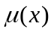, 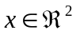, with sup()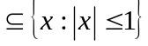such that for some 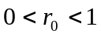, 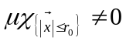 but 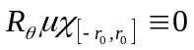. In most practical application, projections on lines passing through a slightly larger region than ROI, that is, given 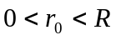, compute the values of a function for all 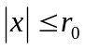, from knowledge of projections of on lines passing through the ball of radiusabout the origin. This is so called semi-local tomography problem which is still not uniquely solvable when is even. However, these functions do not very much inside the ROI, and in fact a crude approximation to the missing projections suffices to approximate well inside the ROI up to an additive constant.
2.3 Reconstruction
The backprojection operator is given by
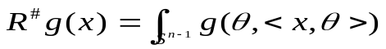 (4)
where and is defined on 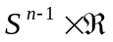. 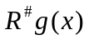is the integral ofover all hyperplanes passing through.
Given on , and 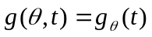, ,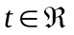, the filtered backprojection formula is defined by
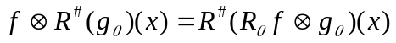 (5)
The basic inversion formula for the Radon transform comes from the projection theorem or Fourier slice theorem (Figure 2), ie., the Fourier transform of the Radon transform with respect to the variable is the Fourier transform of the function along the affine hyperplane.
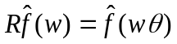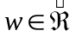 (6)
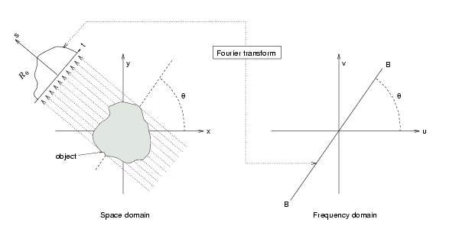
Figure 2 describes the Fourier slice theorem
Taking the inversion of Fourier transform, we can reconstruct the functionfrom the projection databy
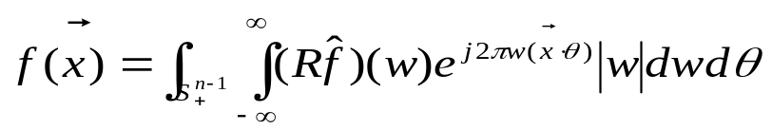 (7)
where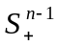 denotes the upper-half sphere of .
The equation (7) can be implemented in two steps, the filtering step, which is the Fourier domain can be written as
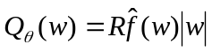 (8)
where 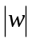 is ramp filter and the backprojection step
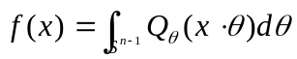 (9)
Note that the equation (6) can be formulated in the space domain as
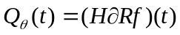 (10)
whereis the Hilbert transform on, and is ordinary differentiation. We will discuss the nolocality of Radon Transform from this point of view in the following section.
2.4. The Nonlocality of Radon Transform Inversion
In the equation (8), the derivative part is a local operator, but the Hilbert transform
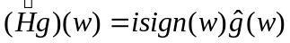 (11)
introduces a discountinuity in the derivative of Fourier transform of a function at the origin. The imposition of the discountunity at the origin in the frequency domain will spread the support of the function in the time domain, that is, the Hilbert transform of a compactly supported function can never be compactly supported. For this reason, a local basis will not remain local after filtering. Moreover, this means that in order to recoverexactly at , all projections of are required not only those passing near .

3. Wavelet Reconstruction
3.1 Why Wavelets?
For the reasons outlined above, we would like a basis of functions which are essentially compactly supported, besides, we want to ensure that the basis functions remain essentially compactly supported after the filtering process, and so will allow a reconstruction from localized data. We considered equation
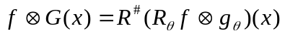 (12)
where 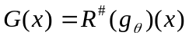. 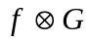 expect to recover locally in even dimension if  has a large number of vanishing moments [11]. By rescaling and by sampling the convolution approximately, one can obtain a wavelet transform of . Wavelets, which are generally constructed with as many zero moments as possible, are thus good candidates for these functions.

3.2 Continuous wavelet Transform
Considering a function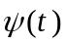on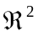satisfies
(13)
and let 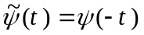, 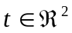, the continuous wavelet transform of function 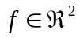 is defined by
(14)
where 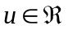, 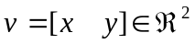, and 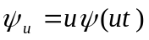.

3.3 Wavelet Reconstruction from the Projection Data
Given a real-value, square integral function on which satisfies equation (14), the wavelet transform of a functioncan be reconstructed from its 1D projections by
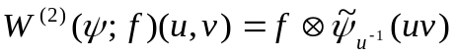
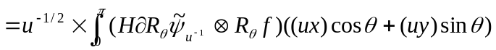 (15)
where , , and . Equation (15) can be implemented using the filtered backprojection method. The right –hand-side can be evaluated in two steps, the filtering step,
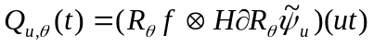 (16)
and the backprojection step
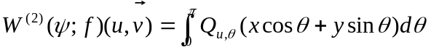 (17)
The filtering part can be implemented in Fourier domain by
(18)
where 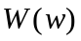is a smoothing window.
In the discrete case, equation (15) become
(19)
where 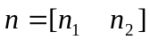. Equation (19) also can be implemented using the filtered backprojection method. The the filtering step,
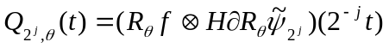 (20)
and the backprojection step
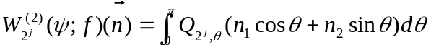 (21)
The filtering part can be implemented in Fourier domain by
(22)
where is a smoothing window.
Equation (18) and (22) can be implemented using the conventional filtered backprojection algorithm, while the ramp filter is replaced by the wavelet ramp filter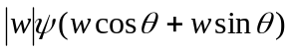
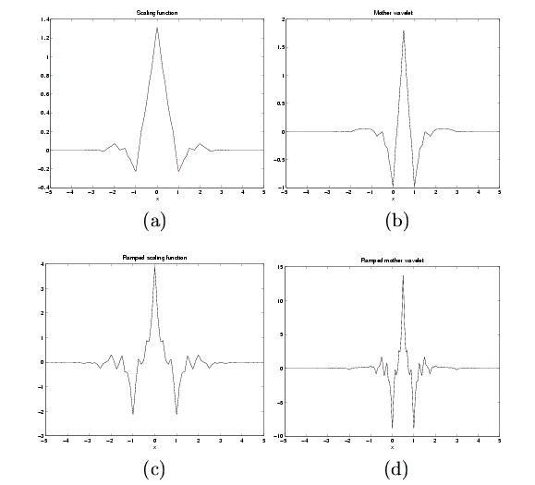
The above figure shows the Daubechies’ biorthogonal wavelet and the scaling function as well as the ramped version of these functions. The ramped version has almost the same compact support as the original version.

4 Implementation
We have implemented part of the wavelet based local tomography algorithm. As stated in the previous sections, the key point of this algorithm is to replace the conventional ramp filter with wavelet ramp filter. The rest of the algorithm can be easily implemented using conventional filtered back projection method. The following paragraphs describe the selected details of the implementation of the wavelet approach. For time and space reason, only one level of the wavelet decomposition is discussed and implemented. Besides, from the 2-D wavelet coefficients from the filtered back projection, we have found that the artifacts are serious. It may be caused by the error in polar to Cartesian coordinates transform. With such serious artifacts, unfortunately, we will not able to evaluate the performance of the wavelet based local reconstruction. Therefore, we did not do the last step of the reconstruction: the inverse wavelet transform. However, we believe we can fully demonstrate our understanding of the problem with the following discussion and attached code.

  - Summary of the algorithms
- Construction of the wavelet filters in Fourier domain. The Fourier transform of the pair of quadrature mirror filters is produced at this step.
- The Fourier transform of the ramp filter and the smoothing window
- Fourier transform of the projection data
- For each projection angle go to step 5)
- Construct in Fourier domain the angle dependent wavelet filter using the angle from 4) and the wavelet filters from 1). The different combination of the two filters given by 1) will result in different reconstructed wavelet transform coefficients in 9), i.e. the approximation coefficients and the other three detail coefficients matrices. For separable wavelet basis, the three detail coefficient matrices represent change along vertical, horizontal and diagonal directions respectively.
- Multiplication of the result given by step 2), 3) and 5), defined by equation (18), which is the equivalent of the convolution in real space
- Go to 4) if there is any unprocessed projection angle. Otherwise go to next step
- Do inverse Fourier transform of the filtered projection
- Conduct conventional filtered back projection. This will give the 2-D wavelet transform coefficients. The four coefficient matrices can be obtained by using various combinations of the two wavelet filters in 5).
- Apply inverse wavelet transform to the forward transform coefficients given by 9) to obtain the reconstructed image.

  - Selected implementation details
In this section, we describe the details for step 1) and step 5) in 4.1. which are the most important steps. The other steps are followed by conventional in filtered back projection algorithm.
Function designWaveletFilter constructs the wavelet filters in Fourier domain. The MakeONFilter (a Wavelab function) loads the scaling function. For example, the discrete form of the db4 scaling filter is:
[0.4830 0.8365 0.2241 -0.1294]
The corresponding wavelet filter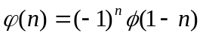, which gives
[0.1294 0.2241 -0.8365 0.4830]
Both filters have to be reversed, because it is the reversed version and that are used to convolute with the signal or image.
The Fourier transforms of and are obtained using function fft. For simplicity, we use 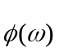 and 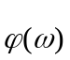 to represent them. The result is returned as the output of the function designWaveletFilter.
Function angledWavelet takes the projection angle and the Fourier transform of the wavelet filters given by designWaveletFilter as input. For a given angle and frequency domain filters, by multiplying the cosine and sine of the angle with the frequencies, the new filters such as 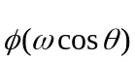 and 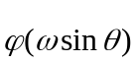 are obtained. Their product is returned as the output of angledWavelet. The output could be 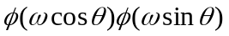,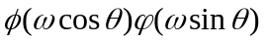,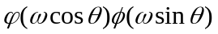and 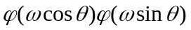

5 Experiment results
Experiments have been done on synthetic data. A synthetic image with only two linear structures and the ‘Shepp-Logan' phantom are used. The first image is used to experimentally verify if the 1D wavelet transform on the projection data gives the 2D wavelet transform, without using inverse wavelet transform to reconstruct the image.

The experiments on the first image show that the wavelet transform is probably correct since the reconstructed 2D wavelet coefficients look right. With the property of the separable wavelet transform, the horizontal and vertical structure should have transform coefficients only in the transform with the corresponding basis. This is exactly illustrated in our experiments. However, the artifact is serious.

For the following figures of 2D reconstructed wavelet coefficients, the figures have been normalized to give a clear view.

 | 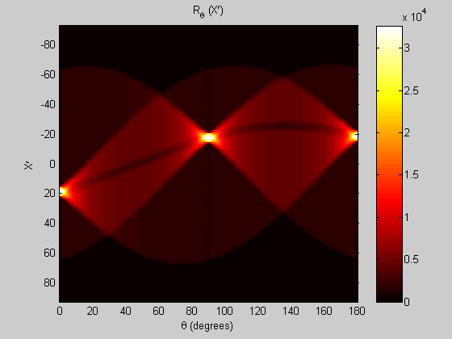 | 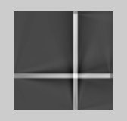
(a) | (b) | (c)
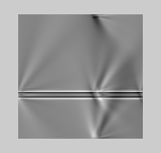 | 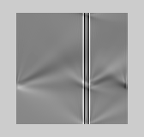 | 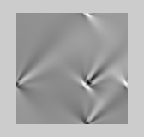
(d) | (e) | (f)
Figure 3: image with linear structures and the reconstructed 2D wavelet transform coefficients. (a) the original image,(b) the radon transform, (c) the approximation coefficients, (d) the detail coefficients along vertical direction, (e) the detail coefficients along horizontal direction, (f) the detail coefficients along diagonal direction

Figure 4 shows the result with the head phantom. If you look the image carefully, you can find that (d) does show more horizontal details, (e) shows more vertical details, (f) shows more diagonal details. Also, the artifact is serious.
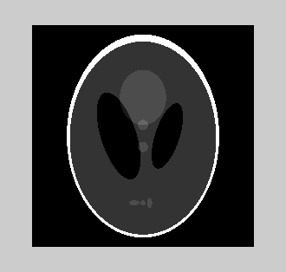 | 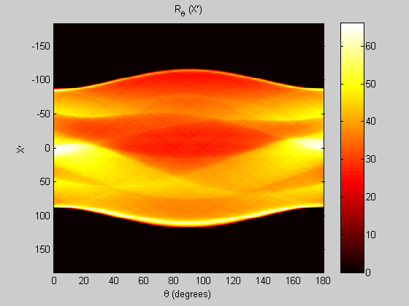 | 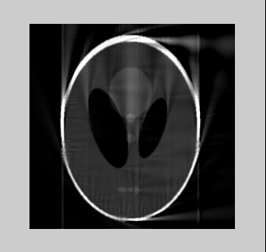
(a) | (b) | (c)
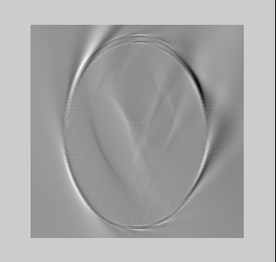 | 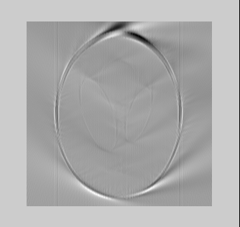 | 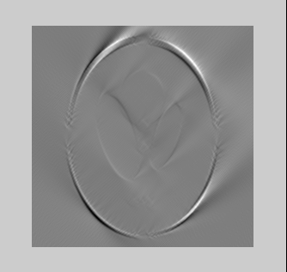
(d) | (e) | (f)
Figure 5: the head phantom and the reconstructed 2D wavelet transform coefficients. (a) the original image,(b) the radon transform, (c) the approximation coefficients, (d) the detail coefficients along vertical direction, (e) the detail coefficients along horizontal direction, (f) the detail coefficients along diagonal direction

6 Conclusions
In this report, we have reviewed the general tomography reconstruction problem and discussed in details the local tomography problems. We justified the application of wavelet transform in the local tomography reconstruction. We implemented the key functions of wavelet based local tomography algorithm coding in MATLAB. Though we have not fully implemented the algorithm, by doing this project, we have gained much insight into the wavelet based local tomography problem.

References
[1] M. Holschneider, Inverse Radon transforms through inverse wavelet transforms, in Inverse Problems, Vol. 7, 1991, pp. 853?61.
[2] G. Kaiser and Streater, Windowed Radon transforms, in Wavelets, A Tutorial in Theory and Applications, C. K. Chui, ed.,Academic Press, New York, 1992, pp. 399-441.
[3] D. Walnut, Application of Gabor and wavelet expansions to the Radon transform, in Probabilistic and Stochastic Methods in Analysis, with Applications, J. Byrnes, et al. eds., Kluwer Academic Publishers, Inc., 187?05, 1992.
[4] J. DeStefano and T. Olson, Wavelet localization of the Radon transform, IEEE Trans. Signal Proc., vol. 42, no.8, Aug. 1994.
[5] A. H. Delaney and Y. Bresler, Multiresolution tomographic reconstruction using wavelets, IEEE Intern. Conf. Image Proc., vol. ICIP-94, pp. 830?34, Nov. 1994.
[6] F. Rashid-Farrokhi, K. J. Ray Liu, C. A. Berenstein, D. Walnut: Localized wavelet based computerized tomography. ICIP 1995: 2445-2448
[7] F. Peyrin, M. Zaim, and G. Goutte, Multiscale reconstruction of tomographic images, in Proc. IEEE-SP Int. Symp. Time-Frequency Time-Scale Anal., 1992.
[8] E. D. Kolaczyk, A wavelet shrinkage approach to tomographic image reconstruction, Journal of the American Statistical Association, 91, 1079-1090 ,1996
[9] M. Bhatia, Williem Clement Karl, Alan S. Willsky, Wavelet-Based Multiscale Stochastic Models for Efficient Tomographic Discrimination of Fractal Fields. ICIP (2) 1994: 135-139
[10] F. Natterer, The Mathematics of Computerized Tomography, Wiley, 1985
[11] C. A. Berenstein and D. F. Walnut, Wavelets in Local Tomography, in Wavelets in Medicine and Biology, Boca Raton : CRC Press Inc., 1996, pp. 231-261.

